



**Electronics Project**

Team Members:

Abdulrahman Khaled Hassan SEC: 1 BN: 32

Omar Ahmed Desoky SEC: 2 BN: 1

Philopateer Nabil SEC: 2 BN: 5

# **3-bit multiplier**

* The design for the logic gates is shown in multiplier gates file.
* The implementation is done using 3 bit adders as shown.
* A and B on the top left are the 3 bit inputs. And result behind them is the output.

* Then multiplier_CMOS contains the design of the same circuit but every element is replaced with it is implementation in CMOS.

## **CMOS AND**

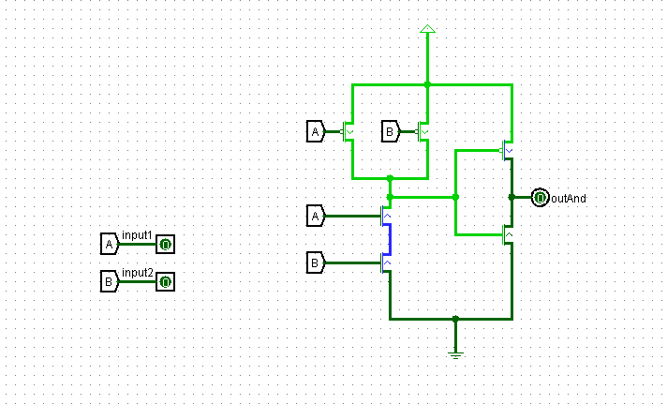

## **CMOS NOT**

## 

## **CMOS XOR**

## **CMOS FULL ADDER**

## **CMOS 3 Bit Adder**

* Then the implementation of the up down counter in counter Gates file.

* Then the counter pass file contains the implementation for this logic gates in pass-transistor logic.
* But the master Slave flip flop is in another file as **feedback problem in Logisim** stops the file from simulation so it is isolated in J-K Flip Flop file.

## **Pass Transistor AND**

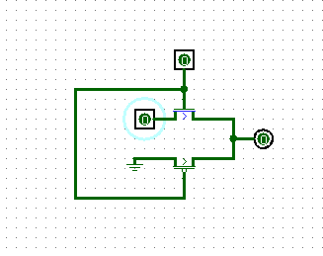

## **Pass Transistor OR**

* Uses NOT gate.

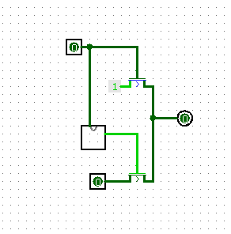

## **Pass Transistor NOT**

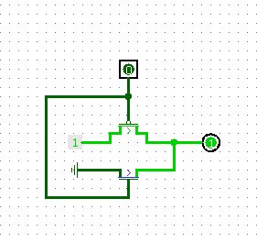

## **R-S latch**

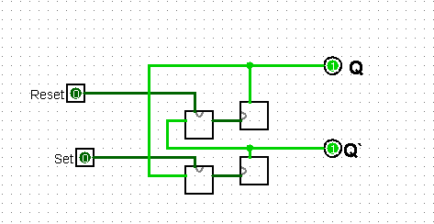

## **J-K master slave FLIP FLOP**

